Memento ViveRe

Team members: Macovei Rares-Stefan

Components

* A race with simple obstacles in which the player has to use portals to overcome them
* A race with color-based obstacles
* A small puzzle in the middle of each level where different mechanics will be in place:
  + 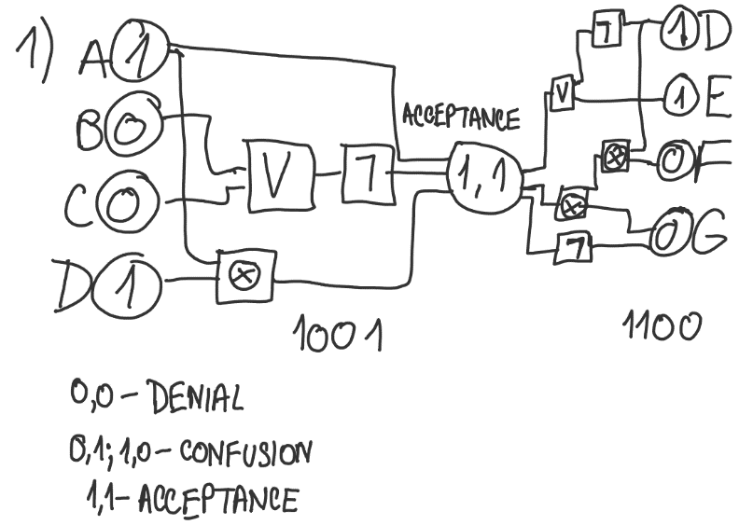logic circuit (denial) = changing the binary inputs to have the output of a collection of different logic gates to 1
  + 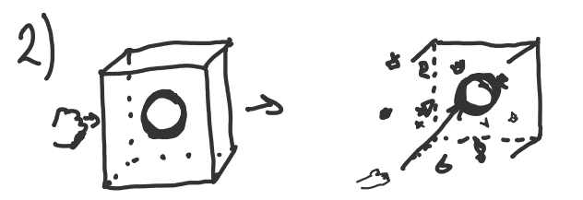superhot-like puzzle(anger) = glass cube with a sphere inside; time moves when the player moves; the player has to punch the cube and then move very slowly to get the sphere, as the sphere mustn’t be touched by the smithereens
  + 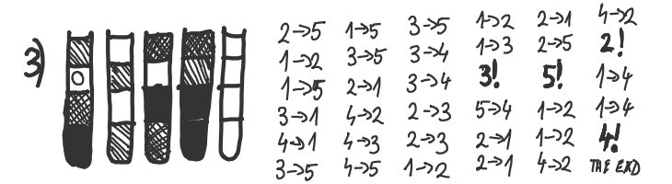water sort puzzle(bargaining)



* + 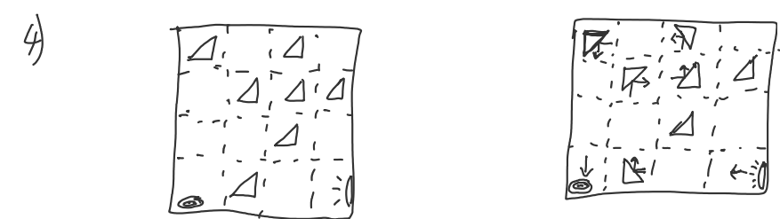mirrors and lights(depression) = rotate mirrors so the light beam gets to a target
  + 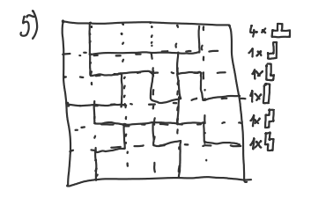placing tetrominoes(a zen experience, signifies acceptance) = place tetrominoes in a rectangle to fill it wholly
* An endless race where the pace increases every period of time

Scenes

* Main menu
* Introduction scene with the Greek gate
* Scenes for the 5 levels
* Scenes for the puzzle in the middle of each level
* Scene for finishing the level
* Scene for the endless level

Models

* The abstract void/being that the player is running from
* The Greek gate
* Black and white environment that turns colored through the level
* Obstacles (walls, spikes, sculptures)
* The three or so lanes where the player can teleport
* The portals
* The portal gun
* The puzzles

Assets

* [Unity Particle Pack](https://assetstore.unity.com/packages/essentials/tutorial-projects/unity-particle-pack-127325)
* [Roman/Greek Environments Bundle | 3D Historic | Unity Asset Store](https://assetstore.unity.com/packages/3d/environments/historic/roman-greek-environments-bundle-264734)
* [Greek Temple Pack | 3D Historic | Unity Asset Store](https://assetstore.unity.com/packages/3d/environments/historic/greek-temple-pack-114537)
* [Greek Statues Set | 3D Historic | Unity Asset Store](https://assetstore.unity.com/packages/3d/environments/historic/greek-statues-set-165265)
* [Portals for VR | VFX | Unity Asset Store](https://assetstore.unity.com/packages/vfx/portals-for-vr-228871)

Animations and sound effects

* The gate at the introduction
* Creating portals
* Going through portals
* Going to the puzzle room
* Breaking glass in the third puzzle
* Light beam in the fourth puzzle
* Finishing the level

Ambiental sounds

* [DEAD STRINGS VOL 5 | Epic Dramatic Violin Epic Music Mix | Best Dramatic Strings Orchestral - YouTube](https://www.youtube.com/watch?v=5CzItIZu3mg&ab_channel=EpicMusicVN)
* [KINGS GAMBIT | Epic Dramatic Violin Epic Music Mix | Best Dramatic Strings by @BrandXMusicOfficial - YouTube](https://www.youtube.com/watch?v=R7ie2x1oiDk)
* [Theseus - The Athenian Hero | Ancient Greek Epic Music - YouTube](https://www.youtube.com/watch?v=gttAK74v5mw&ab_channel=SebastienAngelEpicMusicComposer)
* [Epic Greek Music & Epic Roman Music | Battle, Heroic, War (1 hour) - YouTube](https://www.youtube.com/watch?v=JrtexrCFuVk&ab_channel=BrandonFiechter%27sMusic)

Journey Map

